

We ran the above code to test our `evolve` function. The above code creates 10 random individuals for the population, and runs the evolve function on this population with 10 generations and with 10000 US dollars of investable cash. The evolutionary output we got looked the following:

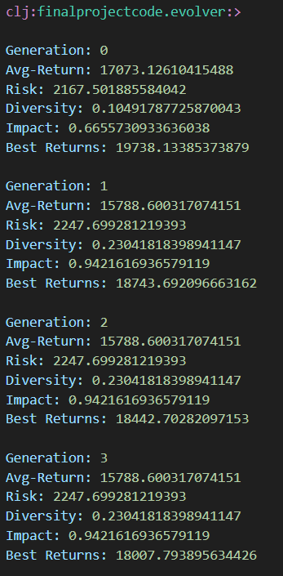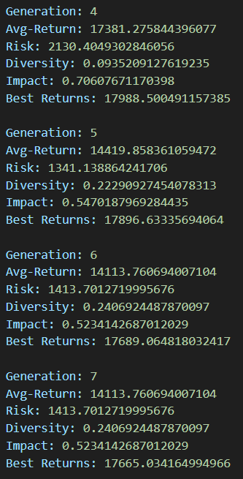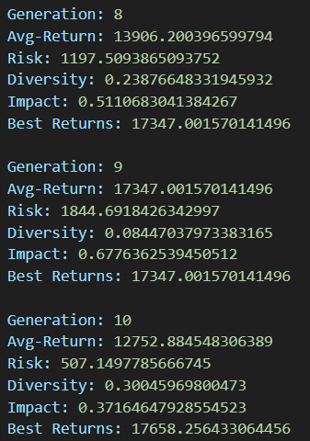

The final optimized weight vector we arrived at was the following:



The different assets in our optimized portfolio were the following:

1. Real Estate (REIT I and RE Fund II)
2. Private Equity (PE Fund II and VC Fund I)
3. Public Securities (Stock IV and Stock I)
4. Inflationary Hedge (2-Year Bond and 12-Month Bond)

The final results we obtained for our optimized weight vector were the following:

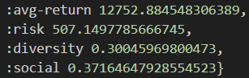

Given all the results above from our testing code, we see that our optimized portfolio invests about 12.8% in Real Estate, 6.03% in Private Equity, 4.45% in Public Securities, and 76.8% in Inflationary Hedges. These percentages were evenly spread out across the two assets in each of the four asset classes. Overall, after 10 generations of evolution and 100 simulated trading days, out optimized portfolio achieved an overall return of 12752 US Dollars. Given that we started with 10000 US Dollars, this means that we achieved a 27.5% positive return overall, which is a very promising amount. This shows how effective evolutionary computing can be in optimizing financial portfolios.

Let us now look at the evolutionary output of the test code. We see that we are trying to optimize our portfolio across 4 different objectives: we are trying to maximize our returns, minimize our overall risk (lower the better), maximize our portfolio diversity (a lower diversity score means a more diverse portfolio since the score is equal to the standard deviation of the weights in the weight vector – more similar weights mean higher diversity), and maximize our social impact score (higher the better). We can see the average values for each of these objectives across selected individuals in each of the 10 different generations. Something to notice is that even though we coded our lexicase selection function to abide by our 4 objectives, each successive generation might not fulfil all 4 of our objectives simultaneously. One of the main reasons for this is that these 4 objectives tend to clash with each other and introduce multiple trade-offs. For example, returns and risk is usually moderately positively correlated with each other, so it is usually hard to maximize returns and minimize risk at the same time. Furthermore, focusing on improving diversity and social impact can sometimes come with the cost of lower returns and higher risk. This is why we sometimes see returns fall, risk rise, diversity decrease, and social impact worsen across subsequent generations. However, overall, we are very happy with our results since it shows a decently high overall return and highly minimized overall risk. We are also contended with the decently high portfolio diversity and social impact score. Nevertheless, there are definitely ways to improve our results and evolutionary procedure in order to further optimize our portfolios.